**DevOps Report 2017/2018**

**Ruth Lennon**

**Team Members:**

Table of Contents

Introduction 3

Agile Approach 3

Scrum Meetings 3

Communication Method 3

System Design 4

Use Case Diagram 4

Class Diagram 4

Website Wireframes 4

Technologies 4

GitHub 4

Jira 4

Jenkins 4

Jacoco 4

Junit 4

JRat 4

JavaDoc 4

Conclusion 4

# 

# Introduction

# Agile Approach

## Scrum Meetings

## Communication Method

# System Design

## Use Case Diagram

## Class Diagram

## Website Wireframes

# Technologies

## GitHub

## Jira

## 

## Jenkins

Jenkins

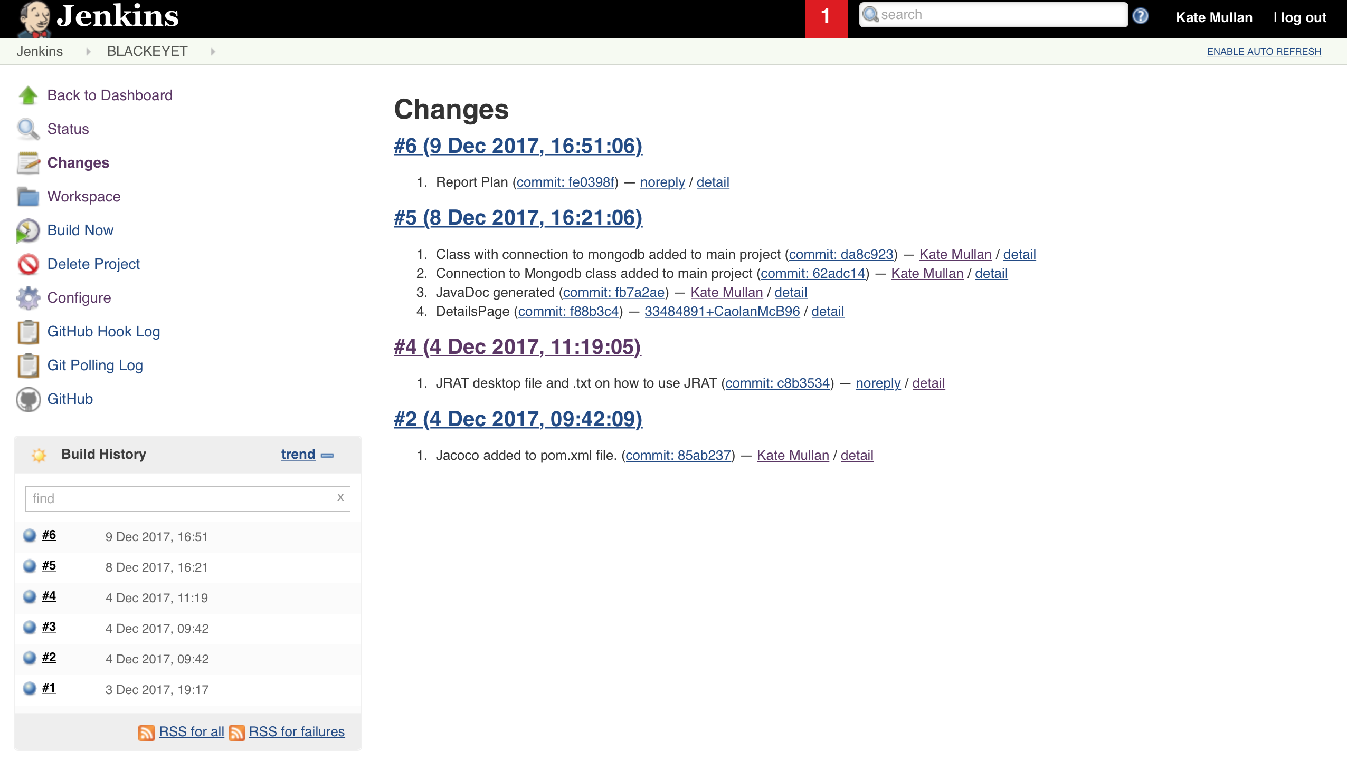

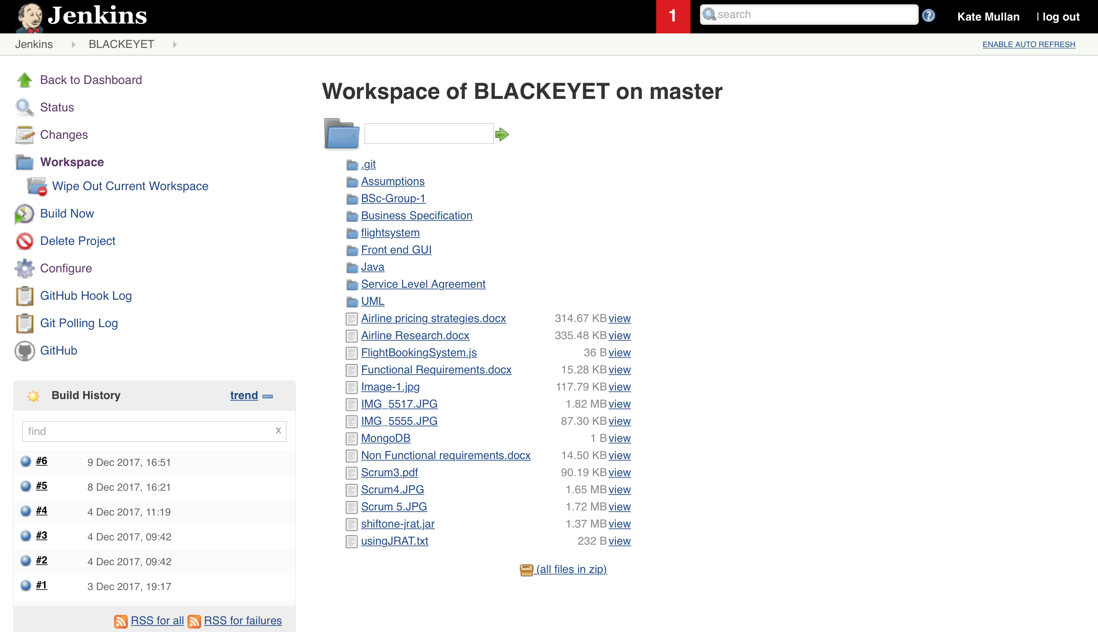

## Jacoco

## Junit

JUnit is designed to write and run tests on Java applications. The framework is open source and free to download as a library contained within a JAR file. The library offers support for the developer to write test cases that will check units within their application. It also provides runtime tools that will execute the test cases and output relevant test results. Junit was used in currencyconverter.java class within the system. Using Junit allows for a

## JRat

## JavaDoc

# Conclusion